Team Charlie

Members: Elijah Wilkinson, Sean Christman, Gabriel Pedraza Torres, Dan Maher

Module: 9.1, Milestone # 1, Case Study: Outland Adventures

02/19/2023

**ERD**

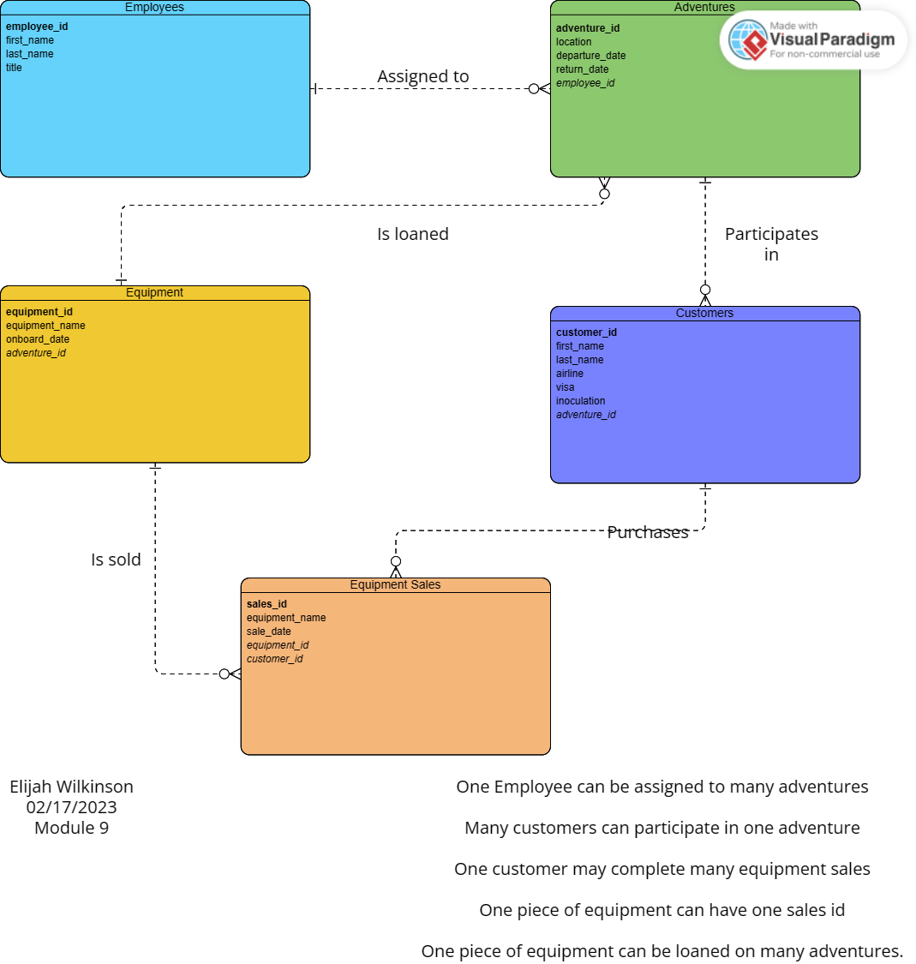

**Business Rules**

* An EMPLOYEE can be assigned to many ADVENTURES
* Many CUSTOMERS can participate in one ADVENTURES
* One CUSTOMER can purchase many pieces of EQUIPMENT(sales.)
* One piece of EQUIPMENT can have one SALES ID
* One piece of EQUIPMENT can be loaned on many ADVENTURES